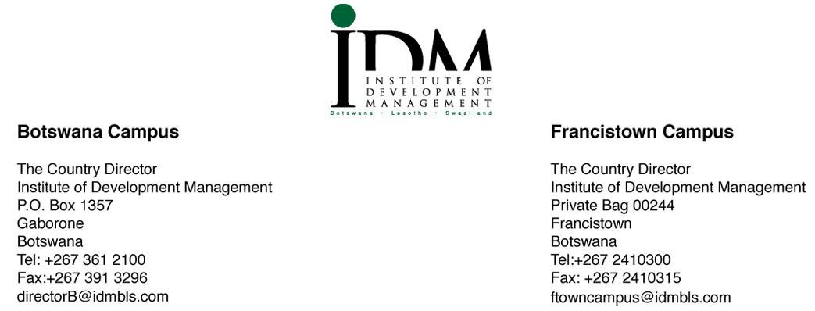

MEMORANDUM
From: IDM IEC
To: IDM Student Body
2020 – 2021 SRC ELECTIONS
SUBJECT: SRC 2020-21 ELECTIONS
This communiqué serves to apprise you that SRC Elections for 2020-21 tenure will be held tomorrow (Thursday 15th). We will be using Caravan M as our polling station which will be open from 0730hrs-1630hrs.
It is also through this memorandum that we take this opportunity to announce the following unopposed candidates as winners in their respective portfolios.
- President- Lawrence Difutswe
- Vice President- Tebogo Lopang
- Minister of Finance- Atamelang Mekgwe
- Minister of Publicity & Marketing- Tumelo Molaodi
- Minister of Gender & Student Welfare – Mpho Gift April
- Minister of Entertainment- Kuda Ngoma

Furthermore be kindly reminded to adhere to the COVID-19 regulations at all times.
Thank you.
……………………….

Resego Joseph
IEC Chairperson

