PROGRAMME | EXAM DATE | Module Code | MODULE TITLE | EXAM DURATION | EXAM VENUE
BA (Hon) Accountancy | 16-March-2026 | ACC5003 | Personal and Business Taxation | 3 Hours (10:00hrs-1300hrs) | IDM MAIN CAMPUS ROOM 1
BA (Hon) Accountancy | 18-March-2026 | ACC5001 | Financial Accounting and Reporting | 3 Hours (10:00hrs-1300hrs) | IDM MAIN CAMPUS ROOM 1
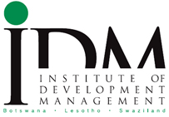UNIVERSITY OF GREATER MANCHESTER EXAMS

REFER/DEFER EXAMS

